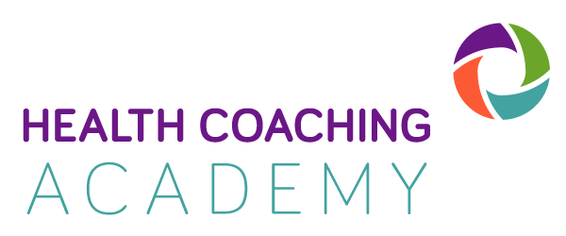
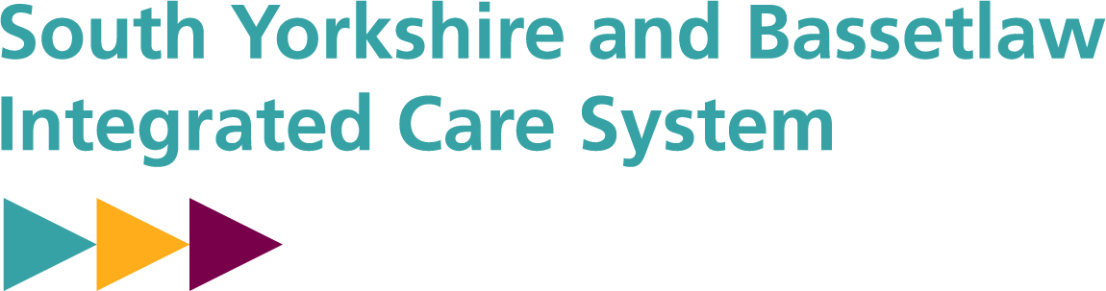

Intermedaite Level
Health and Wellbeing Coaching Skills
Training places available now

We are offering an Intermediate Health and Wellbeing Coaching Skills training day. This 1-day training course is a follow on from the introductory course you have already done.

This additional day of training will boost your confidence, further embed and deepen learning, enhance your techniques and improve your outcomes when providing personalised care.

Delivered by expert coach-trainers, the course contains a mixture of learning, reflection, and practical application to continue your health coaching journey. You will cover:

- Overcoming barriers
- Building motivation
- The power of appreciation
- Offering empowering feedback
- Shared decision making
- Practicing health coaching skills

The course is funded by the South Yorkshire Integrated Care System (SYICS) as part of the regional and national approaches supporting person centred care.

This training is available to Colleagues who work in Health and Social Care, Primary and Secondary Care, Voluntary and Community Organisations. This includes social care and allied professionals, GPs, hospital specialists, community and practice nurses, HCAs, physiotherapists occupational therapists, Link Workers, Social Prescribers, as well as community care colleagues and is ideal for anyone supporting people to have better health and wellbeing outcomes.

You must have completed the Introduction to Health Coaching Course to be eligible for this training.

Dates and Times
You can join this training on 17th May or 14th July, with more dates available later in the year. Joining at 9.15am for a 9.30am start, finishing at 3.30pm.

As spaces are limited, we advise you to sign up as soon as possible by completing the booking form below and returning to kelly.greenwood@nhs.net.

For any queries, please contact Kelly Greenwood kelly.greenwood@nhs.net.

If you would like to know more about the course, visit: www.health-coachingacademy.com

This Health Coaching Skills course is accredited by the Personalised Care Institute (PCI) and counts towards your CPD hours with a certificate upon completion in the Fundaments of Health Coaching.
Attendee Booking Form

Thank you for your interest in taking part in the Health and Wellbeing Coaching Course.
To help with monitoring equality we ask you to complete the following booking form.
The date I would like to attend is: Click here to enter text.
First Name | Click here to enter text.
Surname | Click here to enter text.
Email | Click here to enter text.
Contact Number | Click here to enter text.
Job Title + Role Description | Click here to enter text.
Organisation | Click here to enter text.
Further details (e.g. address of workplace, other, team or area) | Click here to enter text.
Line Manager Details | Name Click here to enter text.  Email Click here to enter text.
Full or Part Time | Full Time ☐ |  |  |  |  |  | Part Time ☐
Type of Contract | Permanent ☐ |  |  |  |  |  | Temporary ☐
Age | 20 and under ☐  21 to 25 ☐  26 to 30 ☐  31 to 35 ☐ | 36 to 40 ☐  41 to 45 ☐  46 to 50 ☐  51 to 55 ☐ |  |  |  |  |  |  | 56 to 60 ☐  61 to 65 ☐  66 to 70 ☐  71 and over ☐
Do you consider yourself to be: | White British ☐  White Irish ☐  Other White ☐  White and Black Caribbean ☐  White and Black African ☐  White and Asian ☐  Other Mixed ☐  Indian ☐  British Indian☐ |  |  |  |  |  |  |  | Pakistani ☐  Bangladeshi ☐  Other Asian ☐  Black Caribbean ☐  Black African ☐  Other Black ☐  Chinese ☐  Any other ☐  Prefer not to say ☐
Do you consider yourself to be | Male ☐ |  |  |  |  | Female ☐ |  |  |  |  | Prefer not to say ☐
 | Prefer to self-describe: Click here to enter text.
Do you consider yourself to have a disability | Yes ☐ |  |  |  | No ☐ |  |  |  |  |  |  | Prefer not to say ☐
If yes please give details: Click here to enter text.
(including any support you would like)
Technical requirements | Please confirm you have access to a laptop or tablet with webcam and microphone capabilities to allow yourself to take part effectively in remotely.
 | Yes ☐ |  |  | No ☐
 | If no please give details: Click here to enter text.
Camera/Personal Space | I confirm I will have my camera on during the training and I will be in a quiet space ☐
Consent  (completing this section will be taken as your eSignature) | I have confirmed my attendance to this course with my line manager ☐  I consent for the information on this form to be recorded to facilitate equality and diversity reviews ☐  I consent for future contact to track impacts from this programme ☐  I consent to sharing my email with other partners of the workshop and attendees on the workshop ☐  I consent to the workshop being recorded for internal teaching and training purposes only☐

Costings organisations outside of South Yorkshire ICS:
We welcome colleagues from outside of South Yorkshire ICS to contribute to and learn from this programme which has been funded by NHS England and South Yorkshire ICS. Contribution charges are as follows:
None Statutory/Voluntary Organisations £25 per person
Statutory /Health/Social Care organisations: £50 per person

We appreciate that everyone is working in busy, complex environments and things can change at the last minute. There is a high demand for this programme and as such if you sign up for the programme and fail to attend without prior arrangement then we will invoice your organisation:

£25 per person for None Statutory Organisations; £50 per person for statutory organisations.

This applies to organisations in or out of South Yorkshire ICS.

Please return to Kelly Greenwood at kelly.greenwood@nhs.net

