‘What Matters to You’ Workshop
What matters most to you?
Health and social care is moving away from asking “what’s the matter with you?” to “what matters to you?” (WMTY). This is a central principle that lies at the heart of person-centred care. This workshop is centred around how to set-up and have a really good ‘WMTY’ conversation, and why it is so important.
We will teach you how you can adopt a coaching mindset and use coaching techniques to practice having a really good WMTY conversation, and consider how you can utilise this at work, at home or with friends.
This sort of conversation, and the associated coaching skills, sits at the heart of person-centred organisations. We all have a role in creating organisations that think and operate like this. We believe that working in a person-centred organisation improves your quality of life, and the life of people you support.
Objectives of the workshop
▪ Engage you in a case for change towards a person-centred approach
▪ Understand coaching approaches that can enable person-centred care
▪ Learn by experience, using the WMTY conversation as an example
▪ Appreciate the role of coaching to enhance your own resilience, as well as those you support ▪ Consider how these approaches could apply in your own workplace
▪ Generate interest in, and plan for further learning.
Who is the workshop for?
This introduction has a broad appeal across all levels of expertise and experience, frontline staff, professional practitioner, administration, leaders and managers. No prior knowledge is necessary and some short pre-course reading will be supplied, to support your learning.
What you can expect
This 3-hour workshop is interactive and practical. We use memorable exercises and examples to stimulate your thinking and interest in coaching. This course is being offered across Sheffield’s health and social care landscape, so expect to learn with an interesting mix of people from a range of settings. We will build on previous local training, like trauma informed thinking and Make Every Contact Count. There will be opportunity to further develop your skills in follow on courses for those most interested.
Our mission is to engage, encourage and challenge the caring professions to work with a coaching mindset to provide person-centred care, in person-centred systems and create the right environment for everyone to thrive, not just survive.”
‘What Matters to You’ Workshop Feedback received
‘The lead facilitators were very skilled, and the materials very accessible to a necessarily broad range of professional roles. The core resources and materials meet the learning objectives very well, but I also enjoyed the scope given to add to this and be flexible.’
‘It was a great introduction to the values of the person centred approach and the methods by which to apply the approach. Because it was an interactive session we got to see how the approach works in different scenarios with different client groups.’
‘It was well planned and allows each participant time to speak and give their views. It allowed me time to think of the approaches I use as a social worker and how I can put what I have learnt into practice.’
‘I found it very useful. Really appreciated the sub groups to allow participants to engage in discussions without feeling overwhelmed by the number. It was insightful to how I thought I was offering patient centred care when really, I was directing them. Good course and would recommend’
‘For me this has been the best online workshop that I have participated in. It was interactive and well managed. It was very informative and enjoyable. I have learnt so much information that will help me in the community.’
‘The workshop was very supportive to all participating, and thank you for taking me with you.’
The word cloud below shows insights on person-centred approaches participants had after the workshop 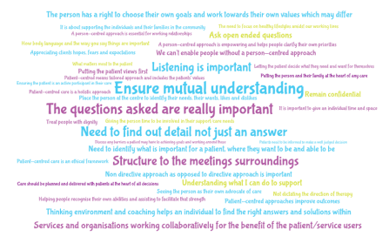
Our mission is to engage, encourage and challenge the caring professions to work with a coaching mindset to provide person-centred care, in person-centred systems and create the right environment for everyone to thrive, not just survive.”
‘What Matters to You’ Workshop
When is it happening?
This is a 3-hour workshop held virtually on the video conferencing app Zoom. The dates and times of the workshop are below:
Thursday 21st April 9.30am - 12.30pm
Thursday 21st April 13.30pm - 16.30pm
Friday 29th April, 13.30pm - 16.30pm
Wednesday 4th May, 9.30am - 12.30pm
Wednesday 22nd June, 9.30am - 12.30pm
Wednesday 29th June, 9.30am - 12.30pm
How do I register?
To register onto one of the workshop dates, participants should complete and return the booking form attached to esme.harvard@nhs.net one week prior to the start-date of registered workshop.
Our mission is to engage, encourage and challenge the caring professions to work with a coaching mindset to provide person-centred care, in person-centred systems and create the right environment for everyone to thrive, not just survive.”

